《离散数学A》上机报告
学 号 | 20251114242 | 姓 名 | 李衡 | 专业班级 | 计科zsb2507
上机地点 | 信-501 | 指导教师 | 梁宇航 | 时 间 | 14：00
上机内容 | 上机1 关系与函数程序设计 |  |  | 成 绩
一、实验目的及要求
1．掌握关系编程运算。
2．掌握函数编程判断。
二、实验设备（环境）及要求
Python IDLE、CodeBlocks、VC++6.0、Eclipse等。
用C语言编程实现，若用其它程序语言例如C++、Java、Python实现，需在本框说明。
三、实验内容与步骤
1．关系的概念
输入集合A和集合B，关系R是从A到B的关系，输入关系R的序偶，并实现以下功能：
（1）输出关系R的集合表达式以及关系矩阵；
（2）输出关系R的定义域domR以及值域ranR。
源程序
#include <stdio.h>
#include <stdlib.h>
#include <string.h>

#define MAX_ELEMENTS 50
#define MAX_PAIRS 100
typedef struct {
char setA[MAX_ELEMENTS];
int sizeA;
char setB[MAX_ELEMENTS];
int sizeB;
int relationMatrix[MAX_ELEMENTS][MAX_ELEMENTS];
char pairs[MAX_PAIRS][2];
int numPairs;
} Relation;

int findIndex(char set[], int size, char element) {
int i;
for (i = 0; i < size; i++) {
if (set[i] == element) {
return i;
}
}
return -1;
}

void inputSet(char set[], int *size, const char *name) {
int i;
printf("输入集合%s的元素个数: ", name);
scanf("%d", size);
printf("依次输入集合%s的各元素 (空格分隔，可以是数字或字母): ", name);
for (i = 0; i < *size; i++) {
scanf(" %c", &set[i]);
}
}
void initMatrix(Relation *rel) {
int i, j;
for (i = 0; i < rel->sizeA; i++) {
for (j = 0; j < rel->sizeB; j++) {
rel->relationMatrix[i][j] = 0;
}
}
}

void inputRelation(Relation *rel) {
int i;
char a, b;
int idxA, idxB;
int validPairs = 0;

printf("\n输入关系R中序偶的个数: ");
scanf("%d", &rel->numPairs);

printf("输入关系的序偶 (格式: a b):\n");
for (i = 0; i < rel->numPairs; i++) {
printf("第%d个序偶: ", i + 1);
scanf(" %c %c", &a, &b);

idxA = findIndex(rel->setA, rel->sizeA, a);
idxB = findIndex(rel->setB, rel->sizeB, b);

if (idxA == -1 || idxB == -1) {
printf(" [错误] (%c, %c) 不符合定义\n", a, b);
i--;
continue;
}

rel->pairs[validPairs][0] = a;
rel->pairs[validPairs][1] = b;
rel->relationMatrix[idxA][idxB] = 1;
validPairs++;
}
rel->numPairs = validPairs;
}

void outputRelationSet(Relation *rel) {
int i;
printf("\n========================================\n");
printf("【关系R的集合表达式】\n");
printf("R = {");
for (i = 0; i < rel->numPairs; i++) {
printf("<%c,%c>", rel->pairs[i][0], rel->pairs[i][1]);
if (i < rel->numPairs - 1) printf(", ");
}
printf("}\n");
}

void outputRelationMatrix(Relation *rel) {
int i, j;
printf("\n【关系矩阵 M(R)】\n");
printf(" ");
for (j = 0; j < rel->sizeB; j++) {
printf("%6c", rel->setB[j]);
}
printf("\n");

for (i = 0; i < rel->sizeA; i++) {
printf("%3c ", rel->setA[i]);
for (j = 0; j < rel->sizeB; j++) {
printf("%6d", rel->relationMatrix[i][j]);
}
printf("\n");
}
}

void outputDomain(Relation *rel) {
int i, j;
char domainSet[MAX_ELEMENTS];
int domainSize = 0;
char element;
int found;

printf("\n【定义域 domR】\n");
printf("domR = {");

for (i = 0; i < rel->numPairs; i++) {
element = rel->pairs[i][0];
found = 0;
for (j = 0; j < domainSize; j++) {
if (domainSet[j] == element) {
found = 1;
break;
}
}
if (!found) {
domainSet[domainSize++] = element;
}
}

for (i = 0; i < domainSize; i++) {
printf("%c", domainSet[i]);
if (i < domainSize - 1) printf(", ");
}
printf("}\n");
}

void outputRange(Relation *rel) {
int i, j;
char rangeSet[MAX_ELEMENTS];
int rangeSize = 0;
char element;
int found;

printf("【值域 ranR】\n");
printf("ranR = {");

for (i = 0; i < rel->numPairs; i++) {
element = rel->pairs[i][1];
found = 0;
for (j = 0; j < rangeSize; j++) {
if (rangeSet[j] == element) {
found = 1;
break;
}
}
if (!found) {
rangeSet[rangeSize++] = element;
}
}

for (i = 0; i < rangeSize; i++) {
printf("%c", rangeSet[i]);
if (i < rangeSize - 1) printf(", ");
}
printf("}\n");
printf("========================================\n");
}

int main() {
printf("========================================\n");
printf("实验一：关系的概念\n");
printf("========================================\n\n");

Relation rel;
memset(&rel, 0, sizeof(Relation));
inputSet(rel.setA, &rel.sizeA, "A");
inputSet(rel.setB, &rel.sizeB, "B");
initMatrix(&rel);
inputRelation(&rel);
outputRelationSet(&rel);
outputRelationMatrix(&rel);
outputDomain(&rel);
outputRange(&rel);

printf("\n按任意键退出...");
getchar();
getchar();

return 0;
}

结果截屏
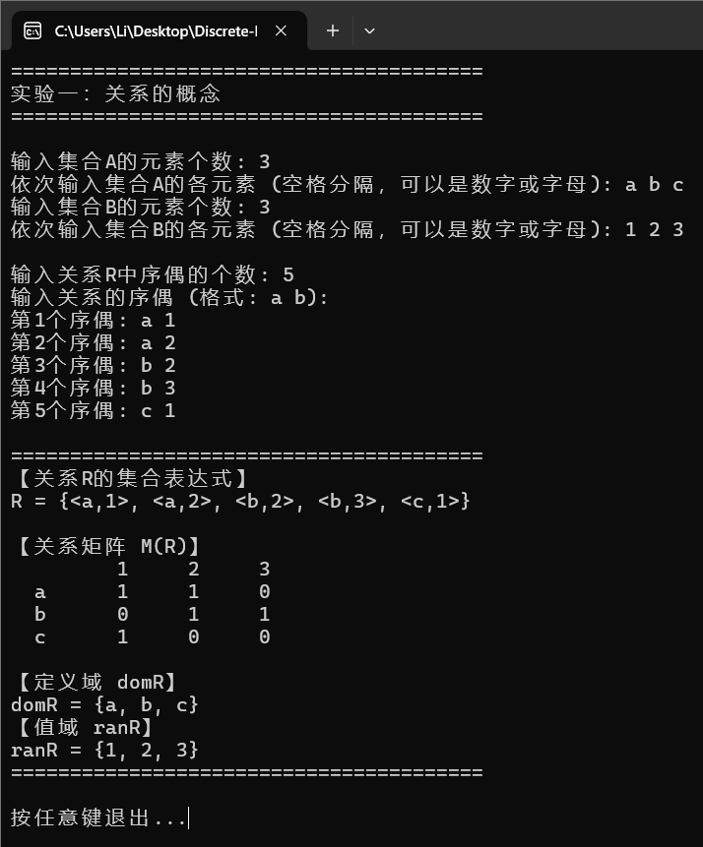

2．关系的性质
输入集合A，关系R是A上的关系，输入关系R的序偶，输出R的关系矩阵，并实现以下功能：
（1）判断关系R是否为自反关系，输出判断结果；
（2）判断关系R是否为反自反关系，输出判断结果；
（3）判断关系R是否为对称关系，输出判断结果；
（4）判断关系R是否为反对称关系，输出判断结果；
（5）判断关系R是否为传递关系，输出判断结果。
源程序
#include <stdio.h>
#include <stdlib.h>
#include <string.h>

#define MAX_ELEMENTS 50
#define MAX_PAIRS 100

typedef struct {
char setA[MAX_ELEMENTS];
int sizeA;
int relationMatrix[MAX_ELEMENTS][MAX_ELEMENTS];
char pairs[MAX_PAIRS][2];
int numPairs;
} RelationA;

int findIndex(char set[], int size, char element) {
int i;
for (i = 0; i < size; i++) {
if (set[i] == element) {
return i;
}
}
return -1;
}

void inputSet(RelationA *rel) {
int i;
printf("输入集合A的元素个数: ");
scanf("%d", &rel->sizeA);
printf("依次输入集合A的各元素 (空格分隔，可以是数字或字母): ");
for (i = 0; i < rel->sizeA; i++) {
scanf(" %c", &rel->setA[i]);
}
}

void initMatrix(RelationA *rel) {
int i, j;
for (i = 0; i < rel->sizeA; i++) {
for (j = 0; j < rel->sizeA; j++) {
rel->relationMatrix[i][j] = 0;
}
}
}

void inputRelation(RelationA *rel) {
int i;
char a, b;
char line[100];
int idxA, idxB;
int validPairs = 0;
int result;

printf("\n输入关系R中序偶的个数: ");
scanf("%d", &rel->numPairs);
getchar(); // 清除换行符

printf("输入关系的序偶 (格式: a b，两个元素用空格分隔):\n");
for (i = 0; i < rel->numPairs; i++) {
printf("第%d个序偶: ", i + 1);

// 使用 fgets 读取一整行，避免缓冲区问题
if (fgets(line, sizeof(line), stdin) == NULL) {
printf(" [错误] 输入失败\n");
i--;
continue;
}

// 用 sscanf 解析一整行
result = sscanf(line, "%c %c", &a, &b);

if (result != 2) {
printf(" [错误] 输入格式不正确，请输入两个元素（如: a b）\n");
i--;
continue;
}

idxA = findIndex(rel->setA, rel->sizeA, a);
idxB = findIndex(rel->setA, rel->sizeA, b);

if (idxA == -1 || idxB == -1) {
printf(" [错误] (%c, %c) 不在集合A中\n", a, b);
i--;
continue;
}

rel->pairs[validPairs][0] = a;
rel->pairs[validPairs][1] = b;
rel->relationMatrix[idxA][idxB] = 1;
validPairs++;
}
rel->numPairs = validPairs;
}

void outputRelationMatrix(RelationA *rel) {
int i, j;
printf("\n【关系矩阵 M(R)】\n");
printf(" ");
for (j = 0; j < rel->sizeA; j++) {
printf("%6c", rel->setA[j]);
}
printf("\n");

for (i = 0; i < rel->sizeA; i++) {
printf("%3c ", rel->setA[i]);
for (j = 0; j < rel->sizeA; j++) {
printf("%6d", rel->relationMatrix[i][j]);
}
printf("\n");
}
}

int isReflexive(RelationA *rel) {
int i;
for (i = 0; i < rel->sizeA; i++) {
if (rel->relationMatrix[i][i] == 0) {
return 0;
}
}
return 1;
}

int isIrreflexive(RelationA *rel) {
int i;
for (i = 0; i < rel->sizeA; i++) {
if (rel->relationMatrix[i][i] == 1) {
return 0;
}
}
return 1;
}

int isSymmetric(RelationA *rel) {
int i, j;
for (i = 0; i < rel->sizeA; i++) {
for (j = 0; j < rel->sizeA; j++) {
if (rel->relationMatrix[i][j] != rel->relationMatrix[j][i]) {
return 0;
}
}
}
return 1;
}

int isAntiSymmetric(RelationA *rel) {
int i, j;
for (i = 0; i < rel->sizeA; i++) {
for (j = 0; j < rel->sizeA; j++) {
if (i != j && rel->relationMatrix[i][j] == 1 && rel->relationMatrix[j][i] == 1) {
return 0;
}
}
}
return 1;
}

int isTransitive(RelationA *rel) {
int i, j, k;
for (i = 0; i < rel->sizeA; i++) {
for (j = 0; j < rel->sizeA; j++) {
for (k = 0; k < rel->sizeA; k++) {
if (rel->relationMatrix[i][j] == 1 && rel->relationMatrix[j][k] == 1) {
if (rel->relationMatrix[i][k] == 0) {
return 0;
}
}
}
}
}
return 1;
}

void checkProperties(RelationA *rel) {
printf("\n========================================\n");
printf("【关系性质判断】\n");

printf("(1) 自反关系: %s\n", isReflexive(rel) ? "是" : "否");
printf("(2) 反自反关系: %s\n", isIrreflexive(rel) ? "是" : "否");
printf("(3) 对称关系: %s\n", isSymmetric(rel) ? "是" : "否");
printf("(4) 反对称关系: %s\n", isAntiSymmetric(rel) ? "是" : "否");
printf("(5) 传递关系: %s\n", isTransitive(rel) ? "是" : "否");

printf("========================================\n");
}

int main() {
printf("========================================\n");
printf("实验二：关系的性质\n");
printf("========================================\n\n");

RelationA rel;
memset(&rel, 0, sizeof(RelationA));
inputSet(&rel);
initMatrix(&rel);
inputRelation(&rel);
outputRelationMatrix(&rel);
checkProperties(&rel);

printf("\n按任意键退出...");
getchar();
getchar();

return 0;
}

结果截屏

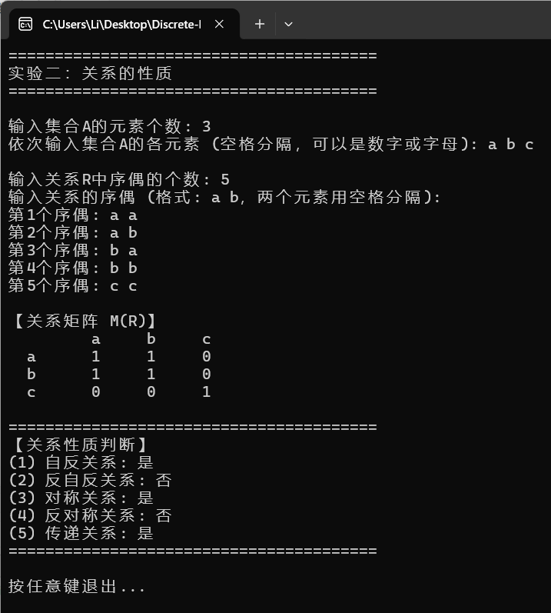
3．关系的复合运算
输入关系R和S的序偶，输出复合运算R○S和S○R后的结果。
源程序
#include <stdio.h>
#include <stdlib.h>
#include <string.h>

#define MAX_ELEMENTS 50
#define MAX_PAIRS 100

typedef struct {
int matrix[MAX_ELEMENTS][MAX_ELEMENTS];
int sizeA, sizeB, sizeC;
char setA[MAX_ELEMENTS];
char setB[MAX_ELEMENTS];
char setC[MAX_ELEMENTS];
} CompositeRelation;

int findIndex(char set[], int size, char element) {
int i;
for (i = 0; i < size; i++) {
if (set[i] == element) {
return i;
}
}
return -1;
}

void outputMatrix(int matrix[][MAX_ELEMENTS], int rows, int cols,
char rowSet[], char colSet[], const char *name) {
int i, j;
printf("\n【%s的关系矩阵】\n", name);
printf(" ");
for (j = 0; j < cols; j++) {
printf("%6c", colSet[j]);
}
printf("\n");

for (i = 0; i < rows; i++) {
printf("%3c ", rowSet[i]);
for (j = 0; j < cols; j++) {
printf("%6d", matrix[i][j]);
}
printf("\n");
}
}

void computeComposite(int R[][MAX_ELEMENTS], int S[][MAX_ELEMENTS],
int result[][MAX_ELEMENTS],
int sizeA, int sizeB, int sizeC) {
int i, j, k;
for (i = 0; i < sizeA; i++) {
for (k = 0; k < sizeC; k++) {
result[i][k] = 0;
for (j = 0; j < sizeB; j++) {
if (R[i][j] == 1 && S[j][k] == 1) {
result[i][k] = 1;
break;
}
}
}
}
}

int main() {
CompositeRelation comp;
int R[MAX_ELEMENTS][MAX_ELEMENTS];
int S[MAX_ELEMENTS][MAX_ELEMENTS];
int result[MAX_ELEMENTS][MAX_ELEMENTS];
int i, j, numR, numS, idxA, idxB, idxC;
char a, b, c;

memset(&comp, 0, sizeof(CompositeRelation));
memset(R, 0, sizeof(R));
memset(S, 0, sizeof(S));
memset(result, 0, sizeof(result));

printf("========================================\n");
printf("实验三：关系的复合运算\n");
printf("========================================\n\n");

printf("输入关系R的信息:\n");
printf("集合A元素个数: ");
scanf("%d", &comp.sizeA);
printf("输入集合A的元素 (空格分隔，可以是数字或字母): ");
for (i = 0; i < comp.sizeA; i++) {
scanf(" %c", &comp.setA[i]);
}

printf("集合B元素个数: ");
scanf("%d", &comp.sizeB);
printf("输入集合B的元素 (空格分隔，可以是数字或字母): ");
for (i = 0; i < comp.sizeB; i++) {
scanf(" %c", &comp.setB[i]);
}

printf("关系R的序偶个数: ");
scanf("%d", &numR);
printf("输入R的序偶 (格式: a b):\n");
for (i = 0; i < numR; i++) {
printf("第%d个: ", i + 1);
scanf(" %c %c", &a, &b);
idxA = findIndex(comp.setA, comp.sizeA, a);
idxB = findIndex(comp.setB, comp.sizeB, b);
if (idxA != -1 && idxB != -1) {
R[idxA][idxB] = 1;
}
}

printf("\n输入关系S的信息:\n");
printf("集合C元素个数: ");
scanf("%d", &comp.sizeC);
printf("输入集合C的元素 (空格分隔，可以是数字或字母): ");
for (i = 0; i < comp.sizeC; i++) {
scanf(" %c", &comp.setC[i]);
}

printf("关系S的序偶个数: ");
scanf("%d", &numS);
printf("输入S的序偶 (格式: b c):\n");
for (i = 0; i < numS; i++) {
printf("第%d个: ", i + 1);
scanf(" %c %c", &b, &c);
idxB = findIndex(comp.setB, comp.sizeB, b);
idxC = findIndex(comp.setC, comp.sizeC, c);
if (idxB != -1 && idxC != -1) {
S[idxB][idxC] = 1;
}
}

printf("\n========================================\n");
outputMatrix(R, comp.sizeA, comp.sizeB, comp.setA, comp.setB, "R");
outputMatrix(S, comp.sizeB, comp.sizeC, comp.setB, comp.setC, "S");

computeComposite(R, S, result, comp.sizeA, comp.sizeB, comp.sizeC);
outputMatrix(result, comp.sizeA, comp.sizeC, comp.setA, comp.setC, "R∘S");

printf("========================================\n");

printf("\n按任意键退出...");
getchar();
getchar();

return 0;
}
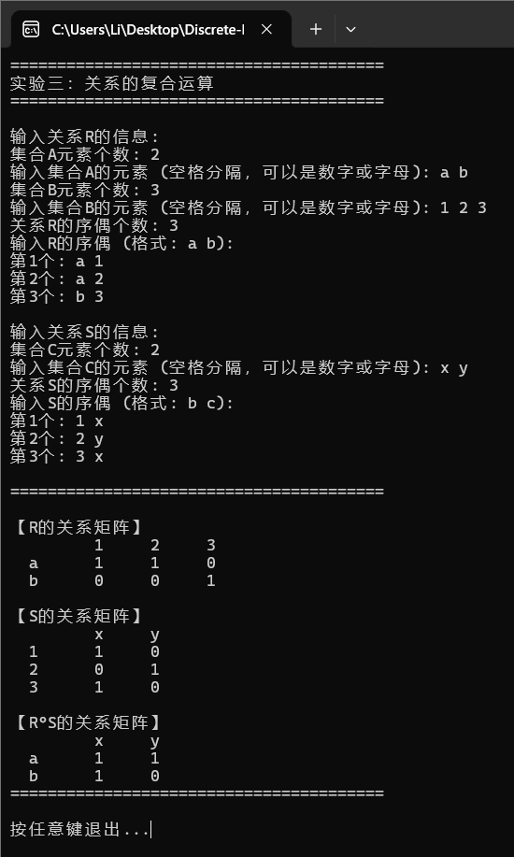
结果截屏
4．关系的闭包
输入集合A，关系R是A上的关系，输入关系R的序偶，输出R的自反闭包和对称闭包。
源程序
#include <stdio.h>
#include <stdlib.h>
#include <string.h>

#define MAX_ELEMENTS 50
#define MAX_PAIRS 100

typedef struct {
char setA[MAX_ELEMENTS];
int sizeA;
int relationMatrix[MAX_ELEMENTS][MAX_ELEMENTS];
char pairs[MAX_PAIRS][2];
int numPairs;
} RelationA;

int findIndex(char set[], int size, char element) {
int i;
for (i = 0; i < size; i++) {
if (set[i] == element) {
return i;
}
}
return -1;
}

void inputSet(RelationA *rel) {
int i;
printf("输入集合A的元素个数: ");
scanf("%d", &rel->sizeA);
printf("依次输入集合A的各元素 (空格分隔，可以是数字或字母): ");
for (i = 0; i < rel->sizeA; i++) {
scanf(" %c", &rel->setA[i]);
}
}

void initMatrix(RelationA *rel) {
int i, j;
for (i = 0; i < rel->sizeA; i++) {
for (j = 0; j < rel->sizeA; j++) {
rel->relationMatrix[i][j] = 0;
}
}
}

void inputRelation(RelationA *rel) {
int i;
char a, b;
char line[100];
int idxA, idxB;
int validPairs = 0;
int result;

printf("\n输入关系R中序偶的个数: ");
scanf("%d", &rel->numPairs);
getchar(); // 清除换行符

printf("输入关系的序偶 (格式: a b，两个元素用空格分隔):\n");
for (i = 0; i < rel->numPairs; i++) {
printf("第%d个序偶: ", i + 1);

// 使用 fgets 读取一整行，避免缓冲区问题
if (fgets(line, sizeof(line), stdin) == NULL) {
printf(" [错误] 输入失败\n");
i--;
continue;
}

// 用 sscanf 解析一整行
result = sscanf(line, "%c %c", &a, &b);

if (result != 2) {
printf(" [错误] 输入格式不正确，请输入两个元素（如: a b）\n");
i--;
continue;
}

idxA = findIndex(rel->setA, rel->sizeA, a);
idxB = findIndex(rel->setA, rel->sizeA, b);

if (idxA == -1 || idxB == -1) {
printf(" [错误] (%c, %c) 不在集合A中\n", a, b);
i--;
continue;
}

rel->pairs[validPairs][0] = a;
rel->pairs[validPairs][1] = b;
rel->relationMatrix[idxA][idxB] = 1;
validPairs++;
}
rel->numPairs = validPairs;
}
void outputRelationMatrix(RelationA *rel, const char *label) {
int i, j;
printf("\n【%s】\n", label);
printf(" ");
for (j = 0; j < rel->sizeA; j++) {
printf("%6d", rel->setA[j]);
}
printf("\n");

for (i = 0; i < rel->sizeA; i++) {
printf("%3d ", rel->setA[i]);
for (j = 0; j < rel->sizeA; j++) {
printf("%6d", rel->relationMatrix[i][j]);
}
printf("\n");
}
}

void reflexiveClosure(RelationA *rel, int closure[][MAX_ELEMENTS]) {
int i, j;
for (i = 0; i < rel->sizeA; i++) {
for (j = 0; j < rel->sizeA; j++) {
closure[i][j] = rel->relationMatrix[i][j];
}
closure[i][i] = 1;
}
}

void symmetricClosure(RelationA *rel, int closure[][MAX_ELEMENTS]) {
int i, j;
for (i = 0; i < rel->sizeA; i++) {
for (j = 0; j < rel->sizeA; j++) {
closure[i][j] = rel->relationMatrix[i][j];
if (rel->relationMatrix[j][i] == 1) {
closure[i][j] = 1;
}
}
}
}

void outputClosure(RelationA *rel, int closure[][MAX_ELEMENTS], const char *type) {
int i, j;
printf("\n【%s闭包的关系矩阵】\n", type);
printf(" ");
for (j = 0; j < rel->sizeA; j++) {
printf("%6d", rel->setA[j]);
}
printf("\n");

for (i = 0; i < rel->sizeA; i++) {
printf("%3d ", rel->setA[i]);
for (j = 0; j < rel->sizeA; j++) {
printf("%6d", closure[i][j]);
}
printf("\n");
}
}

int main() {
printf("========================================\n");
printf("实验四：关系的闭包\n");
printf("========================================\n\n");

RelationA rel;
int reflexiveClosureMatrix[MAX_ELEMENTS][MAX_ELEMENTS];
int symmetricClosureMatrix[MAX_ELEMENTS][MAX_ELEMENTS];

memset(&rel, 0, sizeof(RelationA));
memset(reflexiveClosureMatrix, 0, sizeof(reflexiveClosureMatrix));
memset(symmetricClosureMatrix, 0, sizeof(symmetricClosureMatrix));

inputSet(&rel);
initMatrix(&rel);
inputRelation(&rel);
outputRelationMatrix(&rel, "原关系R的矩阵");

reflexiveClosure(&rel, reflexiveClosureMatrix);
symmetricClosure(&rel, symmetricClosureMatrix);

printf("\n========================================\n");
outputClosure(&rel, reflexiveClosureMatrix, "自反");
outputClosure(&rel, symmetricClosureMatrix, "对称");
printf("========================================\n");

printf("\n按任意键退出...");
getchar();
getchar();

return 0;
}

结果截屏
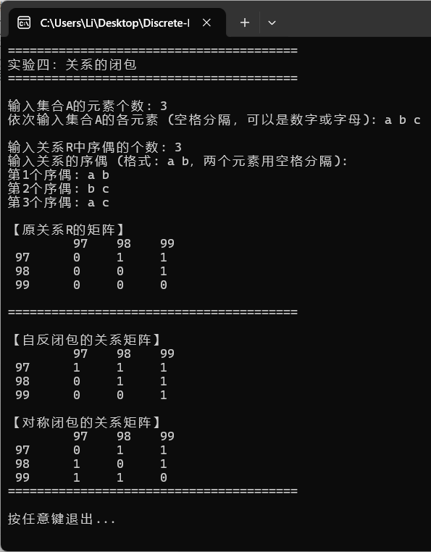
5．函数的定义与类型
输入集合A和集合B，f是从A到B的关系，输入f的序偶，判断f是否为函数，如果是函数判断其函数类型，并输出判断结果。
源代码
#include <stdio.h>
#include <stdlib.h>
#include <string.h>

#define MAX_ELEMENTS 50
#define MAX_PAIRS 100

typedef struct {
char setA[MAX_ELEMENTS];
int sizeA;
char setB[MAX_ELEMENTS];
int sizeB;
int relationMatrix[MAX_ELEMENTS][MAX_ELEMENTS];
char pairs[MAX_PAIRS][2];
int numPairs;
} Function;

int findIndex(char set[], int size, char element) {
int i;
for (i = 0; i < size; i++) {
if (set[i] == element) {
return i;
}
}
return -1;
}

void inputSet(char set[], int *size, const char *name) {
int i;
printf("输入集合%s的元素个数: ", name);
scanf("%d", size);
printf("依次输入集合%s的各元素 (空格分隔，可以是数字或字母): ", name);
for (i = 0; i < *size; i++) {
scanf(" %c", &set[i]);
}
}

void initMatrix(Function *func) {
int i, j;
for (i = 0; i < func->sizeA; i++) {
for (j = 0; j < func->sizeB; j++) {
func->relationMatrix[i][j] = 0;
}
}
}

void inputFunction(Function *func) {
int i;
char a, b;
char line[100];
int idxA, idxB;
int validPairs = 0;
int result;

printf("\n输入关系f中序偶的个数: ");
scanf("%d", &func->numPairs);
getchar(); // 清除换行符

printf("输入关系的序偶 (格式: a b，两个元素用空格分隔):\n");
for (i = 0; i < func->numPairs; i++) {
printf("第%d个序偶: ", i + 1);

// 使用 fgets 读取一整行，避免缓冲区问题
if (fgets(line, sizeof(line), stdin) == NULL) {
printf(" [错误] 输入失败\n");
i--;
continue;
}

// 用 sscanf 解析一整行
result = sscanf(line, "%c %c", &a, &b);

if (result != 2) {
printf(" [错误] 输入格式不正确，请输入两个元素（如: a b）\n");
i--;
continue;
}

idxA = findIndex(func->setA, func->sizeA, a);
idxB = findIndex(func->setB, func->sizeB, b);

if (idxA == -1 || idxB == -1) {
printf(" [错误] (%c, %c) 不在相应集合中\n", a, b);
i--;
continue;
}

func->pairs[validPairs][0] = a;
func->pairs[validPairs][1] = b;
func->relationMatrix[idxA][idxB] = 1;
validPairs++;
}
func->numPairs = validPairs;
}

void outputFunctionSet(Function *func) {
int i;
printf("\n【关系f的集合表达式】\n");
printf("f = {");
for (i = 0; i < func->numPairs; i++) {
printf("<%c,%c>", func->pairs[i][0], func->pairs[i][1]);
if (i < func->numPairs - 1) printf(", ");
}
printf("}\n");
}

void outputFunctionMatrix(Function *func) {
int i, j;
printf("\n【关系矩阵 M(f)】\n");
printf(" ");
for (j = 0; j < func->sizeB; j++) {
printf("%6c", func->setB[j]);
}
printf("\n");

for (i = 0; i < func->sizeA; i++) {
printf("%3c ", func->setA[i]);
for (j = 0; j < func->sizeB; j++) {
printf("%6d", func->relationMatrix[i][j]);
}
printf("\n");
}
}

int isFunction(Function *func) {
int i, j, count;
for (i = 0; i < func->sizeA; i++) {
count = 0;
for (j = 0; j < func->sizeB; j++) {
if (func->relationMatrix[i][j] == 1) {
count++;
}
}
if (count != 1) {
return 0;
}
}
return 1;
}

int isInjective(Function *func) {
int i, j, count;
for (j = 0; j < func->sizeB; j++) {
count = 0;
for (i = 0; i < func->sizeA; i++) {
if (func->relationMatrix[i][j] == 1) {
count++;
}
}
if (count > 1) {
return 0;
}
}
return 1;
}

int isSurjective(Function *func) {
int i, j, found;
for (j = 0; j < func->sizeB; j++) {
found = 0;
for (i = 0; i < func->sizeA; i++) {
if (func->relationMatrix[i][j] == 1) {
found = 1;
break;
}
}
if (!found) {
return 0;
}
}
return 1;
}

void analyzeFunctionType(Function *func) {
printf("\n========================================\n");
printf("【函数类型分析】\n");

if (!isFunction(func)) {
printf("❌ 不是函数\n");
printf("原因：存在A中的元素对应B中0个或多于1个的元素\n");
} else {
printf("✓ 是函数\n");
int injective = isInjective(func);
int surjective = isSurjective(func);

printf(" - 单射(Injective): %s\n", injective ? "是" : "否");
printf(" - 满射(Surjective): %s\n", surjective ? "是" : "否");
printf("\n - 函数类型: ");

if (injective && surjective) {
printf("【双射(一一对应)】\n");
printf(" (既是单射又是满射，存在反函数)\n");
} else if (injective) {
printf("【单射(但非满射)】\n");
printf(" (不同的A中元素映射到不同的B中元素)\n");
} else if (surjective) {
printf("【满射(但非单射)】\n");
printf(" (B中每个元素都有原像，但不是一对一)\n");
} else {
printf("【普通函数】\n");
printf(" (既不是单射也不是满射)\n");
}
}
printf("========================================\n");
}

int main() {
printf("========================================\n");
printf("实验五：函数的定义与类型\n");
printf("========================================\n\n");

Function func;
memset(&func, 0, sizeof(Function));
inputSet(func.setA, &func.sizeA, "A");
inputSet(func.setB, &func.sizeB, "B");
initMatrix(&func);
inputFunction(&func);
outputFunctionSet(&func);
outputFunctionMatrix(&func);
analyzeFunctionType(&func);

printf("\n按任意键退出...");
getchar();
getchar();

return 0;
}

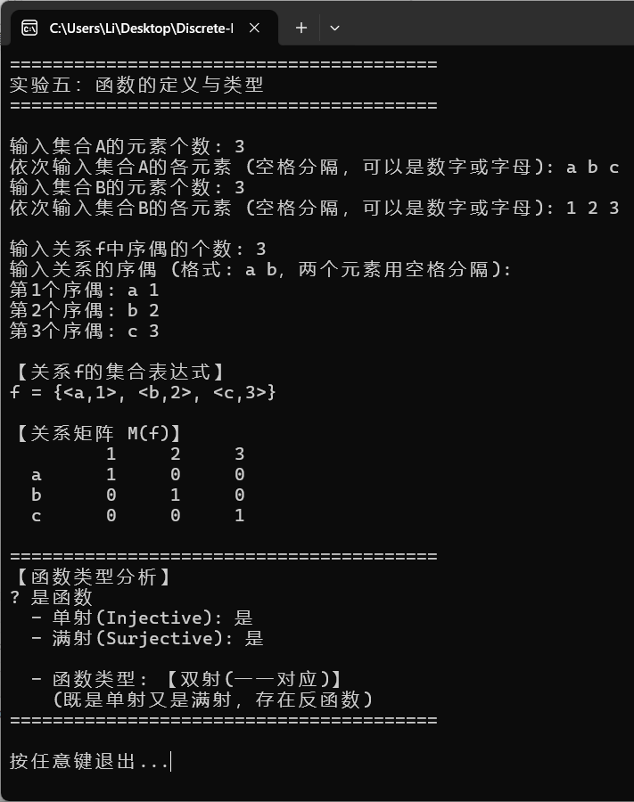
运行截图
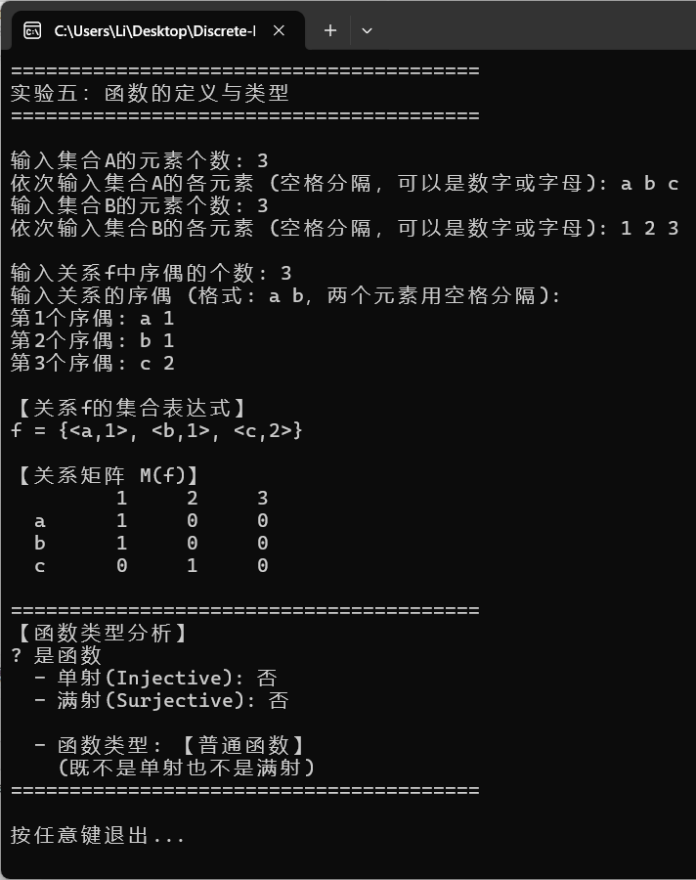
四、收获与体会

